Bravo Challah Recipe
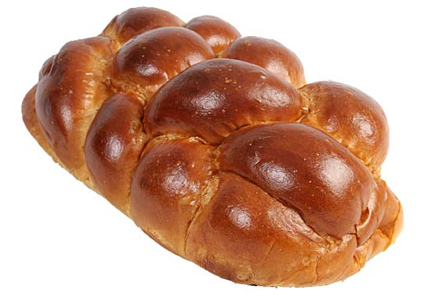
www.makomny.org

Ingredients:

2 eggs
1 cup warm water
½ cup vegetable oil
just under ½ cup sugar
1 teaspoon salt
4 cups flour (if using bread machine, can use flour better for bread machine)
2 teaspoons yeast (or 1 packet)
1 egg yolk
1 tablespoon water

Procedure if using Bread Machine

1. Put eggs, water, vegetable oil, sugar and salt in bread machine container.
2. Add flour.
3. Make small hole in flour and add yeast.
4. Put on dough setting (90 minutes).
5. When finished, punch it down one more time.

Procedure if making By Hand

1. Put yeast in bowl. Add water. Let the yeast activate for 5 minutes.
2. Add flour, eggs, vegetable oil and sugar into bowl. Then add salt.
3. Mix the ingredients together, almost folding the ingredients in.
4. Let the dough rise. Punch it down and let it rise again. Do this at least 2 times.
5. Punch it down one more time.

For Both Bread Machine and By Hand

6. Divide into 2 sections and then divide into 3 or 4 strands, and braid each section (or keep it as one section and make one large challah).
7. Put on cookie sheet sprayed with a little flour.
8. Let it sit at least 30 minutes. (More than a few hours and you will want to keep punching it down or put it in the fridge.)
9. Mix egg yolk with water. Spread on top of challah.
10. Put in 350-degree oven for 22-30 minutes, depending on oven.

Let cool for 15 minutes before eating, and say Hamotzi!

